We’re looking for a few good men, women and youth to help us  learn more about this serious pest of important landscape shrubs,  and trees. You can help us track the spread of this pest, learn  more about its lifecycle and find out which viburnums are most resistant. Here’s how:  - Visit our website (www.hort.cornell.edu/VLB) to learn more about the pest and the project.  - Look for infested viburnums in your yard, local parks, and  natural areas. The larvae feed in late April to June, adults  from late June to frost. You can find eggs almost year-round.  - Record and report what you find via online forms. | 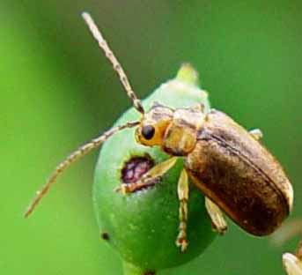  Viburnum leaf beetle adults feed in summer.  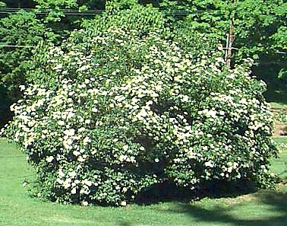  Arrowwood (V. dentatum) flowers in spring and is susceptible to feeding by larvae and adults.  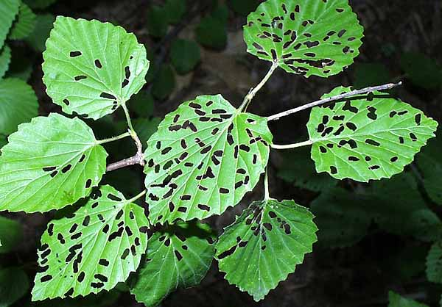  “Skeletonized” leaves damaged by adults.  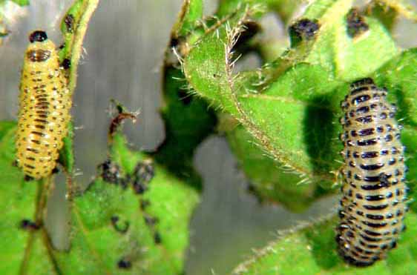  Larvae feed on leaves in spring.  Pictures courtesy Paul Weston, Cornell; Mark Brand, Univ. of Conn.  To learn more about the pest, the plant and the project, visit our website:  www.hort.cornell.edu/VLB
   | Join with other citizen scientists to help fight  Viburnum  Leaf Beetles
  About the pest: :  Viburnum leaf beetles first came to New York from Canada in 1996, causing serious damage to plantings in the Rochester area.  Originally from Europe, the pest faces few natural enemies here, and is spreading quickly across central, western and northern New York, as well as the Southern Tier and parts of neighboring states. It could be poised to move into the Hudson Valley, New York metro area and Long Island.  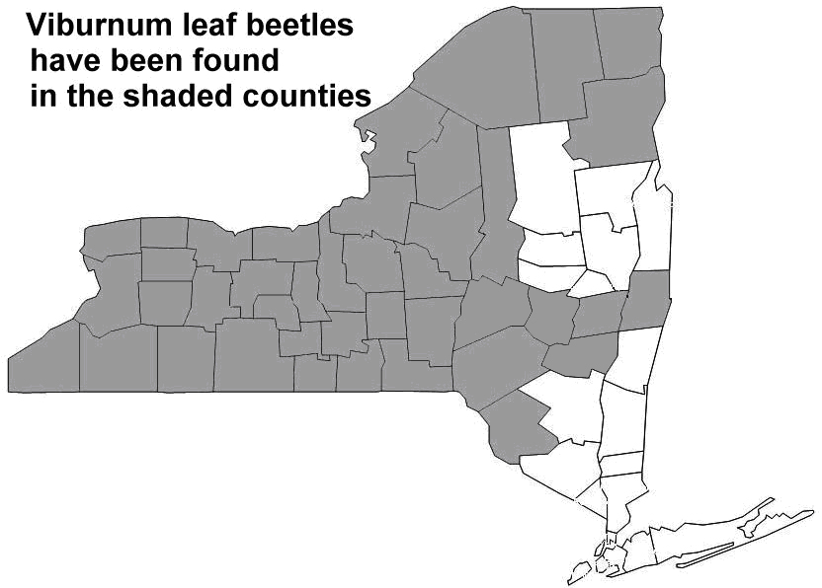 | About viburnums:  Shrubs or small trees, many species of viburnum flourish in the Northeast. Native species  grow in old fields and forests, while imported varieties are versatile landscape plants. Some common viburnums include:  - Korean spice viburnum  - American cranberry bush  - Arrowwood  - Chinese snowball bush  - European cranberry bush  - Hobblebush  - Wayfaringtree  - Blackhaw viburnum

